Name: Name: Date:

Leanne created a route for Jenna to follow on the playground. She started at the edge of the building and ended at the swings. Your job is to help her write directions that follow her path. Use a ruler to measure the path to the nearest centimeter. Each centimeter represents two meters. At each turn tell which direction to turn and how many degrees of a turn. The vision line (dotted line) indicates the direction Jenna will be facing and the direction from which she will turn.
Example:
Fwd 2 meters
Key
1 cm = 2 meter
Turn Left 90˚
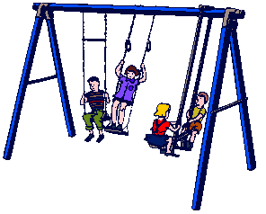
Swing

End
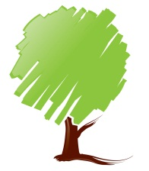
(Vision Line)
(Vision Line)
s
(Vision Line)
Four squares
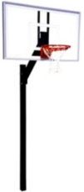
Basketball
(Vision Line)
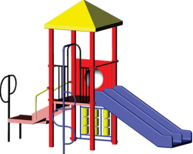
Start
(Vision Line)
Building
(Vision Line)
(Vision Line)
Slide

