Name: ________________________________________ Date: ______________________
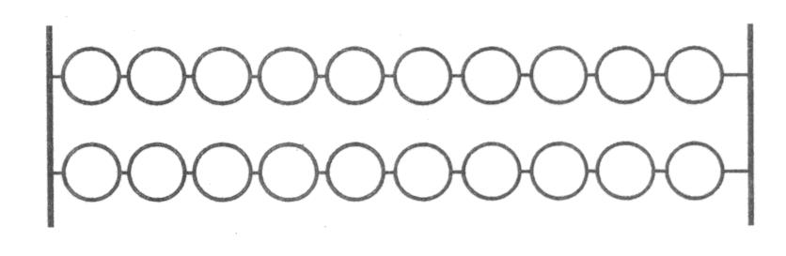
Show all the different ways that 8 children can ride the double decker bus. Write a number sentence for each way you found.

_________________________ __________________________

_________________________ _________________________

_________________________ _________________________

_________________________ _________________________

_________________________ __________________________

How do you know you found all the ways?_______________________________

