Name: _______________ Date: _____________ ____/20
Directions: Draw and name the shape in the box. 2 pts.
This shape has four equal sides and four corners.

This shape is a _______________________________.

This shape has three sides and three corners. 2 pts.

This shape is a _______________________________.

This shape has no sides or corners. 2 pts.

This shape is a _______________________________.
Ghfdyhdhfgddd

Circle A Circle B

Write the sorting rule used to sort these 2-D shapes. 1 pt.

Write the name of each shape on the line below. 1 pt. each

________________ _________________
1 pt. each
Write the name of each 3-D Solid in the boxes below.
Word Bank: Sphere Cylinder Pyramid Sphere
Cone Cube Rectangular Prism

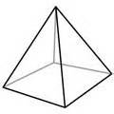
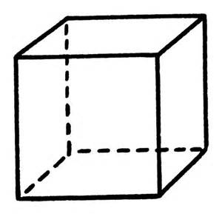

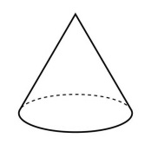
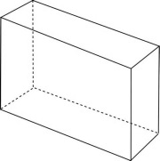

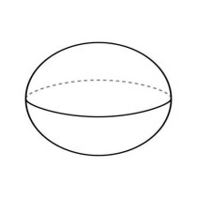

Circle the shapes that show equal parts. 1 pt.

Write a fraction that shows the part shaded. 1 pt. each

__________ ___________

_________ __________

