Name: _______________ Date: _____________ ____/20
Directions: Draw and name the shape in the box.
This shape has four equal sides and four corners.

This shape is a _______________________________.

This shape has three sides and three corners.

This shape is a _______________________________.

This shape has no sides or corners.

This shape is a _______________________________.
Ghfdyhdhfgddd

Circle A Circle B

Write a sorting rule used to sort these 2-D shapes.

Write the name of each shape on the line below.

________________ _________________

Write the name of each 3-D Solid in the boxes below.
Word Bank: Sphere Cylinder Pyramid Sphere
Cone Cube Rectangular Prism

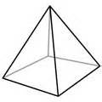
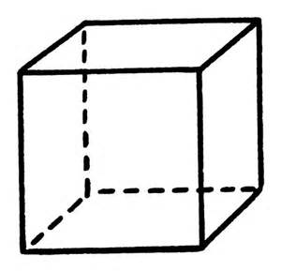

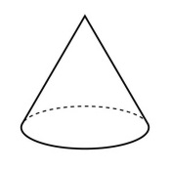
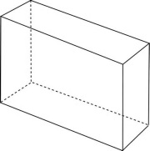

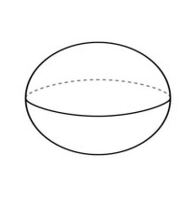

Circle the shapes that show equal parts.

Write a fraction that shows the part shaded.

__________ ___________

_________ __________

