Draw a rectangular shape with the area or perimeter.

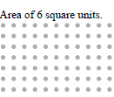
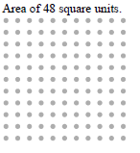
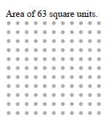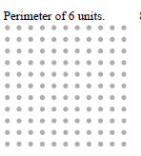

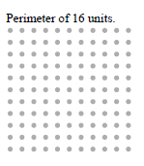
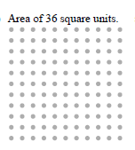

Challenge
Draw a rectangle with an area of 12 sq. in. and a perimeter of 14 in.
Draw a rectangle with an area of 24 sq in. and a perimeter of 22 sq. in.
Draw a rectangle with an area of 36 sq in. and a perimeter of 26 sq. in.

