- Write a story problem for 36 ÷ 4 =
Draw a picture if that helps you write the story problem.

________________________________________________________________________________________________________________________________________________________________________________________________________________________________________________________________________

- Maggie is putting down floor tile on her kitchen floor. The area of the floor is 99 sq. ft. and the width is 9 ft. What is the length of the floor?

__________________________________________________________________

- Maggie decided to put a wooden baseboard around the bottom of the wall when her floor was complete. Use the dimensions of the floor in problem 2 to find the perimeter of the floor.

__________________________________________________________________

Find the area and perimeter for each rectangle.
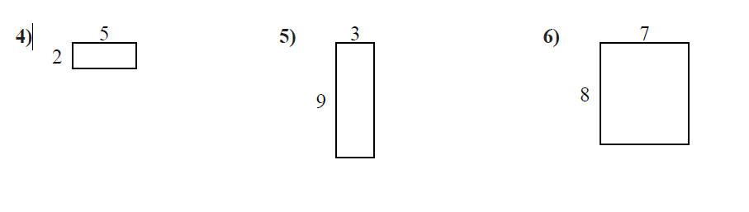
Area_________________ Area_______________ Area_____________
Perimeter_____________ Perimeter___________ Perimeter__________

