Make It Friendly

Materials: Use one inch graph paper and cut out the Make It Friendly Figures sheets.
Display a shape with the grid lines on the overhead, chart, whiteboard or Smartboard. Ask students to T & T and discuss how many square units make up the shape. Remind the students that the inside squares make up the area. Ask students to highlight the different rectangular arrays that compose the shape and challenge students to write a number sentence for each rectangular array. Show how the different parts of the rectangular array determine the total area in square units. Challenge students to represent the shape using different rectangular arrays and match a number sentence to each example students present.

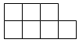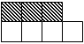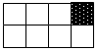
? (1 x 3) + (1 x 4) or (2 x 3) + (1 x 1) or (2 x 4) – (1 x 1)
3 + 4 = 7 in² 6 + 1 = 7in² 8 - 1 = 7inch²
Another example:

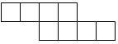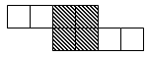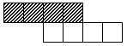
? (1 x 2) + (2 x 2) + (1 x2) or (1 x 4) + (1 x 4)
2 + 4 + 2 = 8in² 4 + 4 = 8in²
Tell the students that today they are going to find area of shapes using multiplication arrays of a variety of shapes by decomposing the shapes into rectangular arrays. Ask them to record the matching number sentence for each shape at least two different ways for decomposing the shape. Then ask them to consider which is the most efficient (or fewest) ways of recording the rectangular arrays that compose the shape. As you confer with students explicitly point out that the answer is in “square units.”
Other examples:
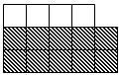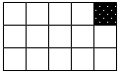
(3 x 4) + (2 x 1) or (1 x 4) + (2 x 5) or (3 x 5) – (1 x 1)
12 + 2 = 14in² 4 + 10 = 14in² 15 - 1 = 14in²

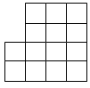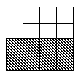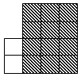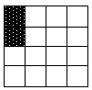
? (2 x 3) + (2 x 4) or (2 x 1) + (4 x 3) or (4 x 4) – (1 x 2)
6 + 8 = 14in² 2 + 12 = 14in² 16 - 2 = 14in²

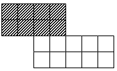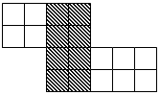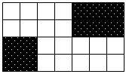
(2 x 4) + (2 x 5) or (2 x 2) + (4 x 2) + (2 x 3) or (4 x 7) – (2 x 2) – (2 x 2)
8 + 10 = 18in² 4 + 8 + 6 = 18in² 28 - 4 - 4 = 18in²

