Name:
Area and Perimeter
Find the area and perimeter. Remember to label your answers correctly!
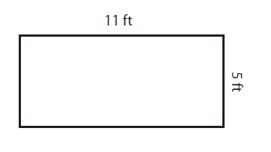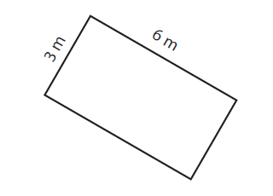
Area: ______________ Area: ______________
Perimeter: ______________ Perimeter: ______________

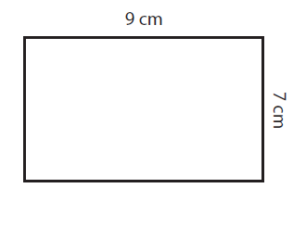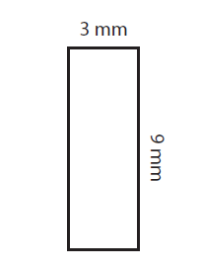
Area: ______________ Area: ______________
Perimeter: ______________ Perimeter: ______________

