Materials
- Book or hard object (the wall)
- Ping pong ball, rubber ball, marble, or recess ball
- Paper, white 8 ½ x 11 or chart paper, (soft carbon paper could also be used)
- Tape
Directions:
- Tape the paper against the book or wall
- Roll the ball at the book (or wall).
- Mark on the paper where the ball enters the paper. (Approaching ray)
- Mark on the paper where the ball bounces off the book (wall).
- Mark on the paper where the ball exits the paper. (Reflected ray)
- Connect the marks for the approaching ray.
- Connect the marks for the reflected ray.
- Draw a line segment that is perpendicular to the book (wall) at the point where the ball hit.
- Measure the approaching angle from both the wall and from the perpendicular line segment with your protractor.
- Measure and compare the reflected angle.
- Repeat this process for three trials and note any observations.
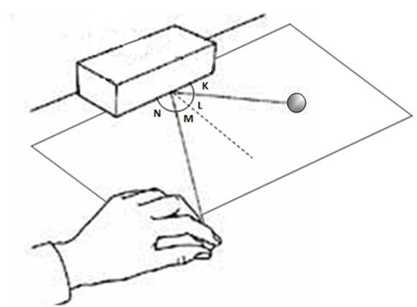

Name:
Name:
Name:
 | Approaching Angle  from the baseline | Reflected Angle from the baseline | Approaching angle from the perpendicular | Reflected angle from the perpendicular
Trial 1:

Trial 2:

Trial 3:

Trial 4:

Trial 5:

Trial 6:

Compare the angle measures. What patterns do you notice?

Variation on this investigation:
- (Version 2)

  - Do the same task as outlined in the lesson but use chart paper on the floor against the wall and use a playground ball. Or,

  - Do the same task as outlined in the lesson above but use a ruler ramp to start the ball. This will provide a more accurate starting point for the approaching ray.
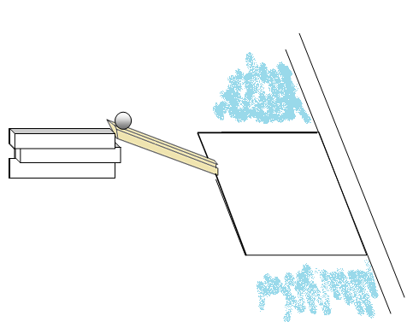
- (Version 3) Use rays of light:
    - Make a slit in a box (shoe box)
    - Place a flashlight in the box and direct it at a mirror
    - Use modeling clay to support a mirror on the desk (or symmetry mirror)
    - Place paper in front of the mirror
    - Direct the box (light) at an angle across the paper toward the center of the mirror.
    - Trace and label the approaching ray and the reflected ray
    - Use a protractor to measure and compare the angles.

