Fairfield Gr 4 U5 Extension 2 S2 Pie Chart Problem
The pie chart below represents the amount of money that Sam budgeted for a weekend trip to a beach cabin.
- 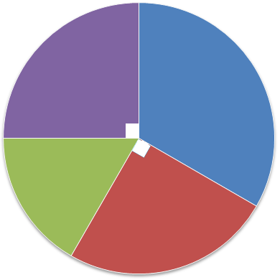
Transportation

Food
$150

Cabin Rental
$200

Miscellaneous things like beach chair, sun-block, beach towels, books to read, etc…

- What fraction of the total budget went to transportation?

- What is the total amount of money she budgeted for the trip?

- What is the measurement of the angle for the miscellaneous things?

- What is the fractional part of the whole chart is the miscellaneous things?

- How much money did she budget for miscellaneous things?

- What fractional part of the total budget did she spend on the cabin rental?

