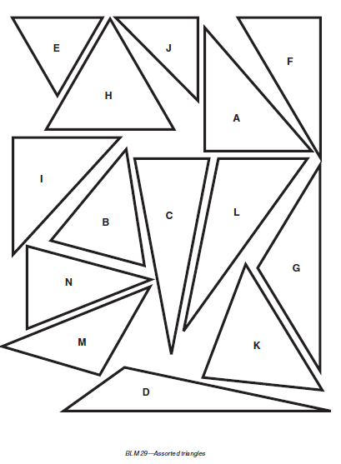

Directions: Label the angles in the triangles as acute, obtuse or right.