Name:

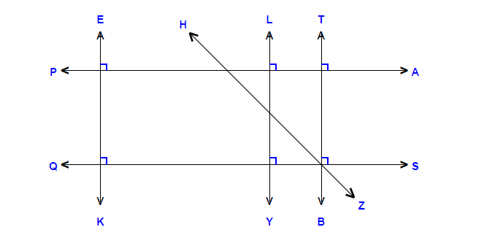

Name the following:
ray __________________
line segment __________________
line __________________
parallel lines __________________
perpendicular lines __________________
intersecting lines __________________

Using a protractor draw your own acute angle and obtuse angle and label how many degrees:
An acute angle An obtuse angle

_______° _______°

