Fairfield Gr 4 U5 L10 S1 Fun with Angles

- Draw a line segment.

- Draw a 45˚ and 135˚ line segment of same length
from each end-point of the first line segment.

- Connect the end-points of the two segments
in step two with a line segment parallel to
the first line segment.

- Draw two perpendicular line segments from the
first line segment. And another from one end of
the parallel line segment.

- Draw a line segment parallel to the first line
Segment, connecting the two perpendiculars
line segments.

- Draw a line segment parallel to the line segment that
was 135˚ off the first line segment.

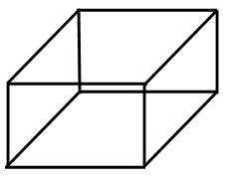
- A few more parallel lines can
change the image.
An extension of this activity is to draw the same image, but instead of parallel lines, use a vanishing point. *See the Art teacher.

