Fairfield Gr4 U5 L11 S1 KEY Missing Angles sheet I
Complementary angles

1.
Write an estimate for the angle measure.
Measure one angle.
What is the complementary angle measure and how did you find it?

B

X

Y

M

Estimate of ∠YBX ˚

∠YBX 50˚

∠MBY 40˚

How did you find ∠MBY?

2.
L

P

N

M

Estimate of ∠MLN ˚

∠MLN 25˚

∠NLP 75˚

How did you find ∠MBY?

Q

S

T
R

3.

Estimate of ∠QRS ˚

∠QRS 60˚

∠SRT 30˚

How did you find ∠MBY?

4.
Estimate of ∠UOA ˚
E

U

O
A

∠UOA 80˚

∠AOE 10˚

How did you find ∠AOE?

5.
K

J

I

H

Estimate of ∠HIJ ˚

∠HIJ 85˚

∠JIK 5˚

How did you find ∠JIK?

6.

D

G

F

E

Estimate of ∠EDF ˚

∠EDF 30˚

∠FDG 60˚

How did you find ∠FDG?

Missing Angles sheet II
Supplementary angles

1.
B

Z

J
F
Estimate of ∠JFZ ˚

∠JFZ 90˚

∠ZFB 90˚

How did you find ∠ZFB?

2.
L

P

M

R

Estimate of ∠MRP ˚

∠MRP 100˚

∠MRL 80˚

How do you did you find ∠MRL?

3.
Y

V

Z

X

Estimate of ∠XYV ˚

∠XYV 60˚

∠XYZ 120˚

How did you find ∠XYZ?

4.
B

D

C

F

Estimate of ∠CDB ˚

∠CDB 45˚

∠CDF 135˚

How did you find ∠CDF?

5.

Estimate of ∠IUO ˚
E

O

I

U

∠IUO 25˚

∠OUE 155˚

How did you find ∠OUE?

6.

W

N

L

M

Estimate of ∠LWM ˚

∠LWM 55˚

∠WMN 125˚

How did you find ∠WMN?

KEY Missing Angles sheet III

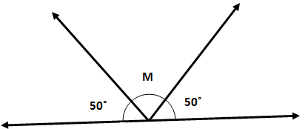
1.
∠M 80˚

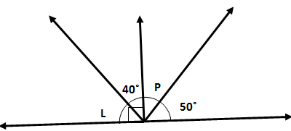
2.
∠L 50˚
∠P 40˚

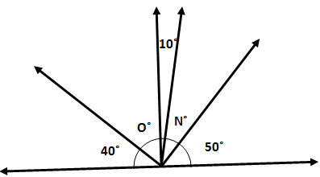
3.
∠N 30˚
∠O 50˚

4. Lines NJ and MK are parallel.
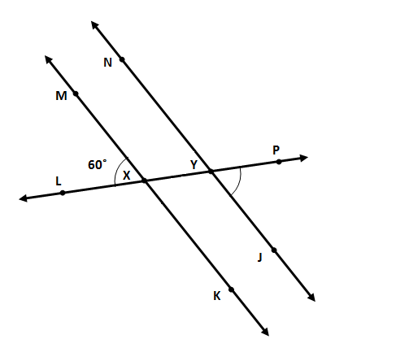
∠MXL 60˚
∠JYP 60˚
∠KXL 120˚
∠NYL 60˚
∠NYP 120˚
∠MXK 180˚

R

25˚

T

S

Q

L

5.
∠Q 25˚
∠R 65˚
∠S 155˚
∠T 65˚
∠L 25˚

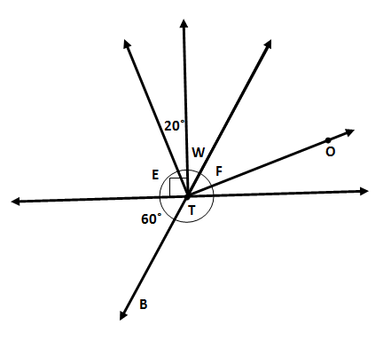

6.
∠BTO 140˚
∠E 70˚
∠W 30˚
∠F 40˚

