Fairfield Gr 4 U5 L11 S1 Missing Angles sheet I
Complementary angles

Name: ____________________________
1.
Write an estimate for the angle measure.
Measure one angle.
What is the complementary angle measure and how did you find it?

B

X

Y

M

Estimate of ∠YBX ˚

Measure ∠YBX ˚

∠MBY ˚

How did you find ∠MBY?

L

P

N

M

2.

Estimate of ∠MLN ˚

Measure ∠MLN ˚

∠NLP ˚

How did you find ∠NLP?

E

U

O
A

3.
Estimate of ∠UOA ˚

Measure ∠UOA ˚

∠AOE ˚

How did you find ∠AOE?

4.
K

J

I

H

Estimate of ∠HIJ ____ ˚

Measure ∠HIJ ˚

∠JIK ˚

How did you find ∠JIK?

Fairfield GR 4 U5 L11 Missing Angles sheet II
Supplementary angles

Name: _____________________
1.

Estimate of ∠JFZ ˚
B

Z

J
F

Measure ∠JFZ ˚

∠ZFB ˚

How did you find ∠ZFB?

L

P

M

R

2.

Estimate of ∠MRP ˚

Measure ∠MRP ˚

∠MRL ˚

How did you find ∠MRL?

Y

V

Z

X

3.

Estimate of ∠XYV ˚

Measure ∠XYV ˚

∠XYZ ˚

How did you find ∠XYZ?

B

D

C

F

4.

Estimate of ∠CDB ˚

Measure ∠CDB ˚

∠CDF ˚

How did you find ∠CDF?

Fairfield GR 4 U5 L11 Missing Angles sheet III

Name: _______________________
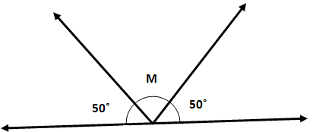
1.
∠M ˚

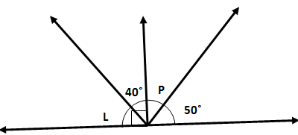
2.
∠L ˚
∠P ˚

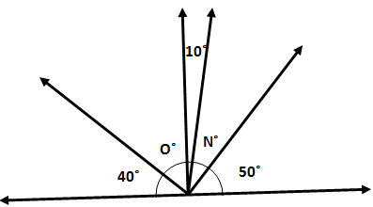
3.
∠N ˚
∠O ˚

4. Lines NJ and MK are parallel.
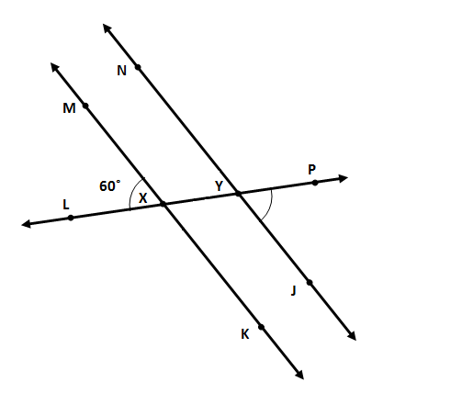
∠MXL 60˚
∠JYP ˚
∠KXL ˚
∠NYL ˚
∠NYP ˚
∠MXK ˚

R

25˚

T

S

Q

L

5.
∠Q ˚
∠R ˚
∠S ˚
∠T ˚
∠L ˚

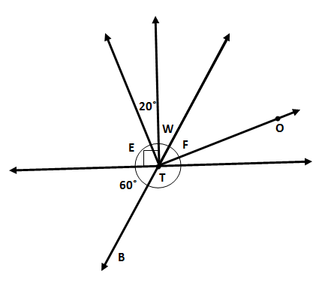

6.
∠BTO ˚
∠E ˚
∠W ˚
∠F ˚

