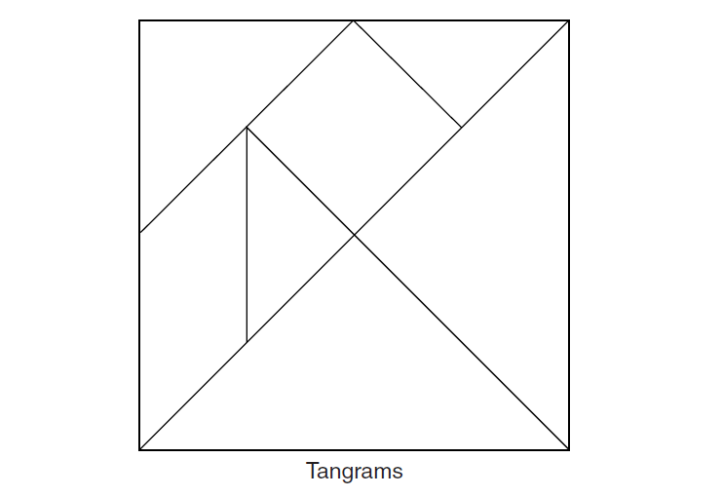

DIRECTIONS: Label all of the shapes in these Tangrams.

Challenge: Can you label the shapes in more than one way?

