Name:

Properties of Regular Polygons
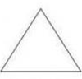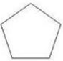

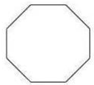

Properties of sides:

Properties of angles:

Properties of diagonals:
Note: Diagonals are perpendicular or not
Bisected by the other or not
Congruent or not

Properties of symmetry (line and point):

