Regular and Irregular Polygons
A regular polygon is a polygon (a many sided closed figure) where all angles are equal in measure (angles are congruent) and all sides have the same length (sides are congruent). Regular polygons may be convex (every interior angle is less than 180˚).

http://2.bp.blogspot.com/_0nQJKlHdKGQ/TGozz5FGXBI/AAAAAAAAAAo/emZllAjRdLA/s1600/types+of+polygons.JPG, 6/30/2011

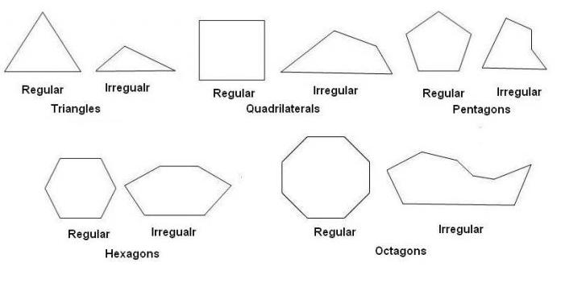
Irregular
Irregular

