Measuring a Turn

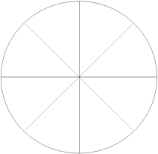
- Fold paper in half along the bold line (hotdog fold) to make a semicircle.

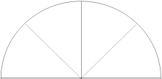
- Fold semicircle in half along the solid line.

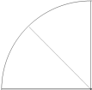
- With scissors, carefully cut the arch of the circle
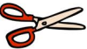
- Once cut, fold long the dotted line.

- Then open and label the creases on the outer edge of the circle.

