Fairfield Gr 4 U5 L5a S1 How to Use a Protractor to Measure Angles

Step 1: Line up the protractor on one ray (side) of the angle, the initial ray (1)
Step 2: Place the center of the protractor on the vertex of the angle, the end-point where the two rays meet. (2)
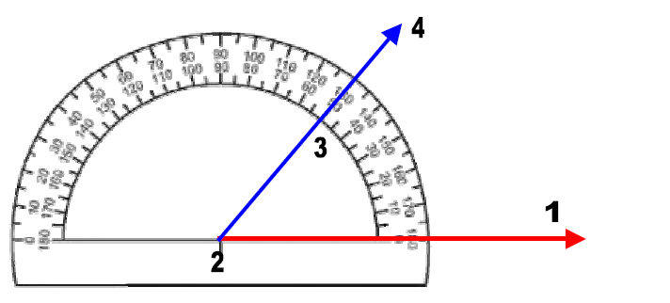
Step 3: Read the degree of angle measure of the terminating ray (3). If it is an acute angle it will be less than 90˚(3). If it is an obtuse angle it will be greater than 90˚. The angle measured above measures 50˚ (3). The numbers on the outer edge of the protractor (4) would measure the supplementary angle.

