Name:
Practice With Angle Measurement
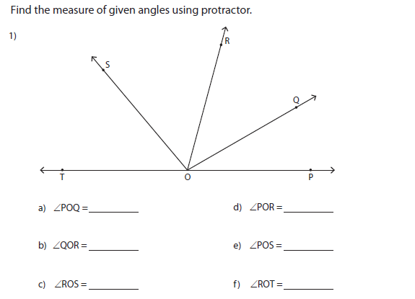

Draw an angle for the following measurements:
2) 60°

3) 25°

