Name
More Practice With Angle Measurement

1)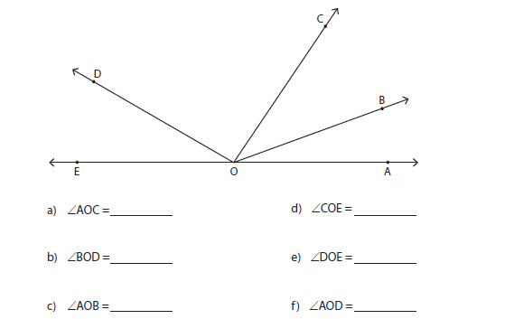

Draw an angle for the following measurements:
2) 80°

3) 45°

