Name: Date:
Estimate the average weight of each item below. Then find the average weight.
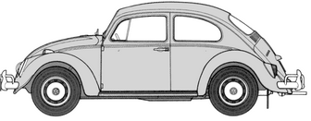
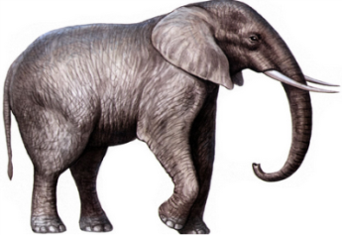
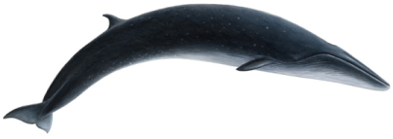
Volkswagon
Elephant
Sei Whale

Estimate:

Actual:

What is the difference in weight between the heaviest and lightest?
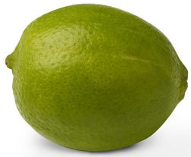
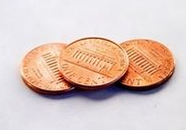
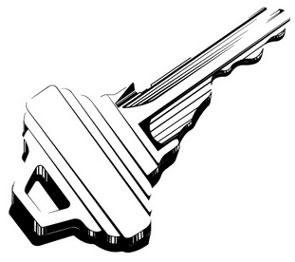
Lemon
Pennies
Key

Estimate:

Actual:

What is the difference in weight between the heaviest and lightest?

