Handmade balance

Side view:

Clip board

Dowel or long pencil

Binder clip

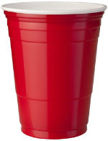

Meter stick or yard stick

String

Cup

