|  |  |
| --- | --- |
| 1 cup | 8 oz. |
| 1 pint | 16 oz |
| 1 quart | 32 oz. |
| 1/2 gallon | 64 oz |
| 1 gallon | 128 oz |

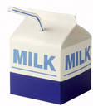

**½ Pint**

**8 oz.**

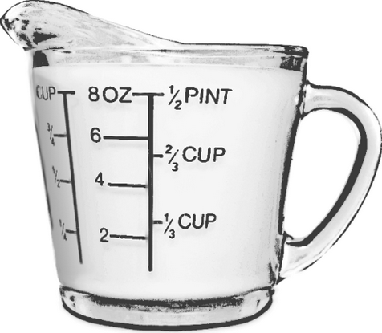

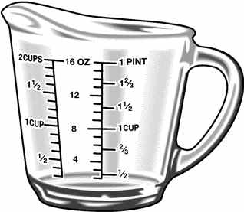

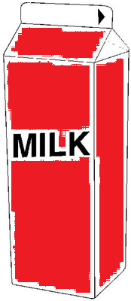

**1 Qt**

**32 oz.**