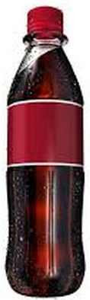
Name:

Soda is on sale for $1.12 for a 16 oz. bottle. Filling up my car took 15 gallons at $2.99 per gallon.
- How much would it cost if we bought 1 gallon of soda at this price?
- How much would it cost for 15 gallons of soda at $1.12 for 16 oz bottle?

