Below is one approach to finding the solution to the party punch problem.
- How much of each ingredient needs to be purchased to serve over 100 people?

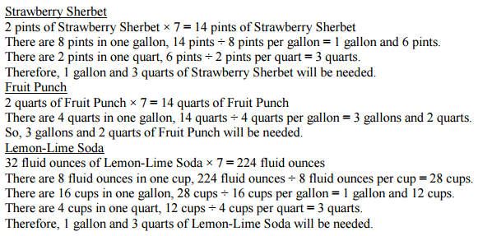

- How many total gallons of punch can be made with the all the ingredients?

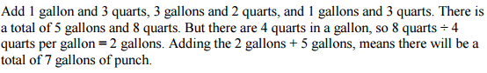

- If there were only 12 fl. oz. cups, how many servings could be made from the total number of gallons? [Optional]
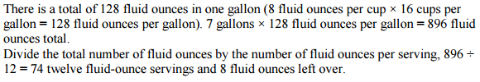
Lesson adapted from:
https://www.georgiastandards.org/Common-Core/Common%20Core%20Frameworks/CCGPS_Math_4_Unit7Framework.pdf p. 102

