Ping-pong Ball Race

Use a straw to blow a Ping-Pong ball around the perimeter of a rectangle. The object of the game is to travel the greatest distance in the shortest amount of time.
Sylvia took 24 seconds to travel the width (short end) of the rectangle which is 12 inches. The length of the rectangle is three times as long as the width. If she kept up that pace, how long would it take her to complete the perimeter of the rectangle?
How much distance did Sylvia cover?

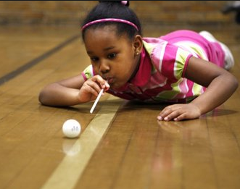
12”
Pedro took 36 seconds to complete the width of his rectangle which is 18 inches. The length of the rectangle is three times as long as the width. If he kept up that pace, how long would it take him to complete the perimeter of the rectangle?
18”

How much distance did Pedro cover?

Who do you think covered the greatest distance in the shortest amount of time? How could we figure out who covered the greatest distance in the shortest time?

Journal Question:

Bret did the ping-pong ball race on her desk. The width of her rectangle was 12 inches and the length was double the width. If it took her 20 seconds to go the width, how long would it take her to travel the perimeter if she kept her pace?
What the perimeter of her rectangle?
What was the area of her rectangle?

