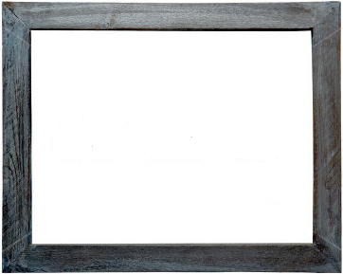

12 ½ inches

18 ⅛ inches

|  |  |
| --- | --- |
| **Seconds** | **Minutes** |
| 60 | 1 |
| 120 |  |
| 135 |  |
| 240 |  |
|  | 5 |