Kindergarten – Unit 2 Parent Letter

We are beginning Unit 2: Identifying, Describing, Comparing, Analyzing, Composing 2-dimensional and 3-dimensional Shapes. The purpose of this unit is to develop an understanding of shapes and positional language. Students will analyze and compare both 2-dimensional and 3-dimensional shapes to describe their similarities and differences. They will identify shapes within their environment and will trace and draw basic shapes in order to construct more complex shapes. Students will also use positional language such as above, beside, below and in front of, to describe the positions of objects.
Some examples of the work your child will be doing are:
- Students will use pictures and manipulatives to learn positional language such as inside, behind, underneath, next to, on top of, right, left etc.

- Students will identify and sort 2D and 3D shapes based on their attributes.
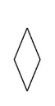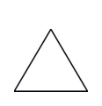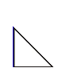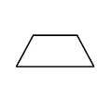
Rhombus Rhombus Triangle Triangle Trapezoid

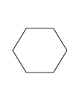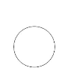
Hexagon Circle Square Rectangle
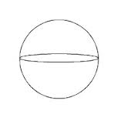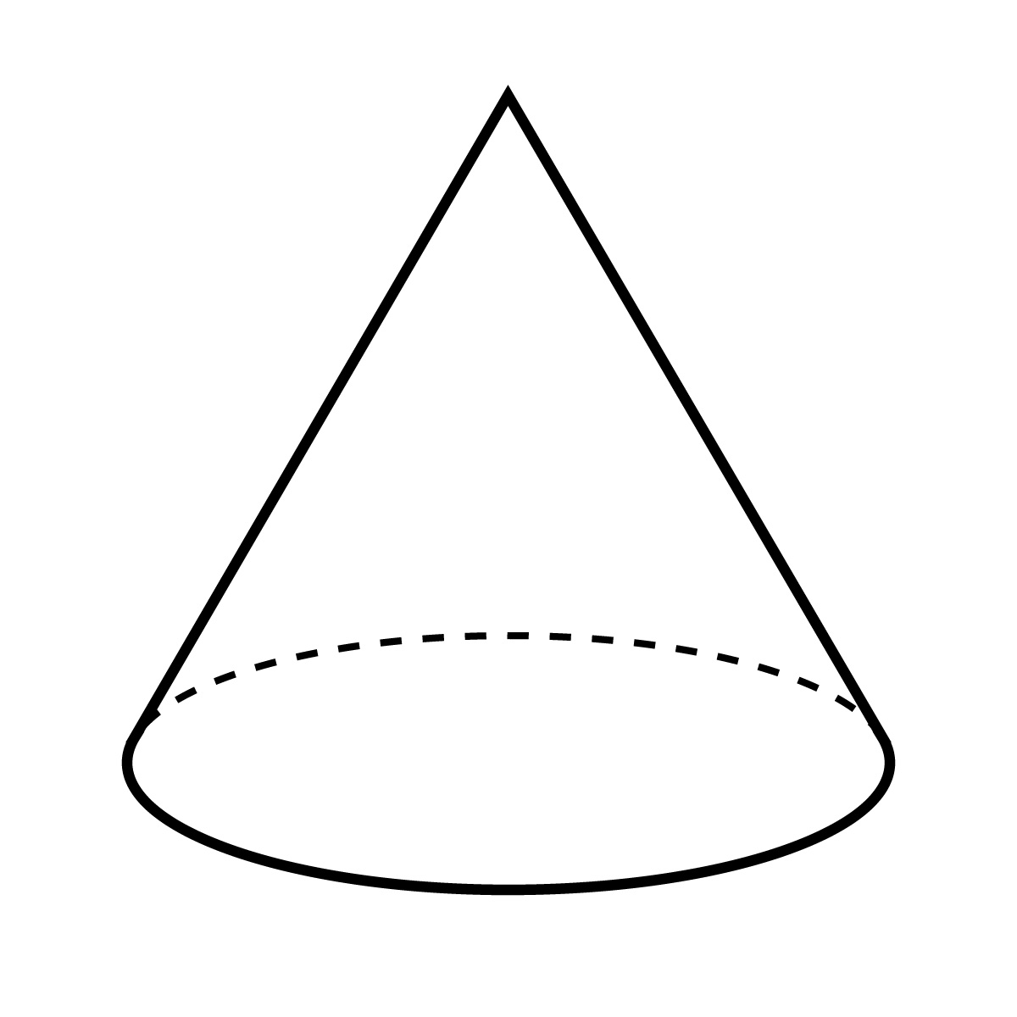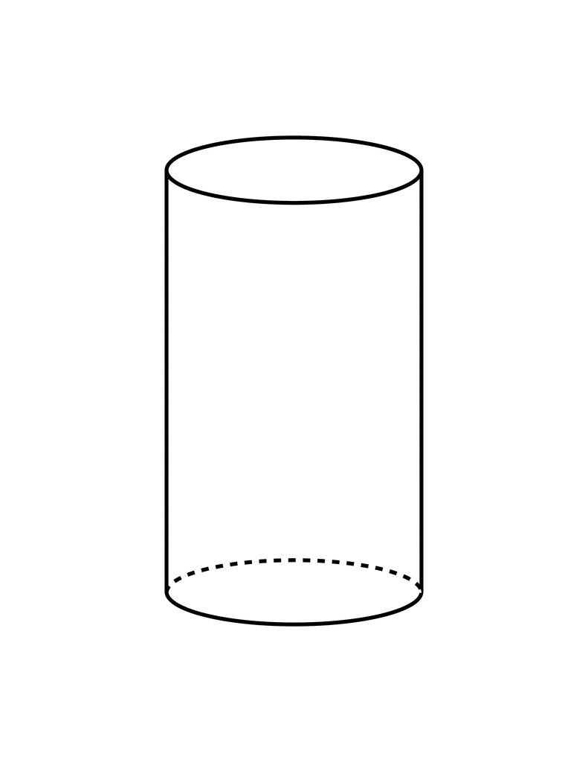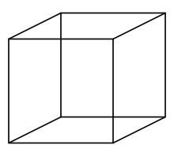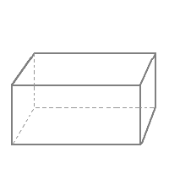
Sphere Cone Cylinder Cube Rectangular prism

- Students will identify 2D and 3D shapes within their environment as well as within different sizes and orientations.

- Students will compose (create) and decompose larger shapes using smaller shapes.

Here is how you can help your child while our class is working on this unit:

- Identify shapes that are found at home. Ask: what shape is our table? Cabinets? Rug? Couch cushions?
- Identify shapes that make up other shapes at home; example: two triangles together can make up one square or rectangle.
- Ask your child to identify similarities and differences amongst shapes each group.
- Read shape books with your child.
- Continue with counting practice by asking your child to count how many squares, triangles, circles, etc they can find in a game or around the house.

If you have any questions, please contact your child’s teacher or the Math Science Teacher.

For additional information, take a look at the Fairfield Public School Parent Guide at http://fairfieldpublicschoolsk5math.wikispaces.com/home

