Name:
Line Plot Practice
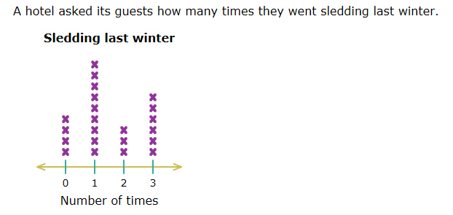
How many guests went sledding more than one time? ____________________
What is the most popular number of times to go sledding? ____________________
What is the difference between the number of guests who went sledding the least and the number of guests who went sledding the most? ____________________

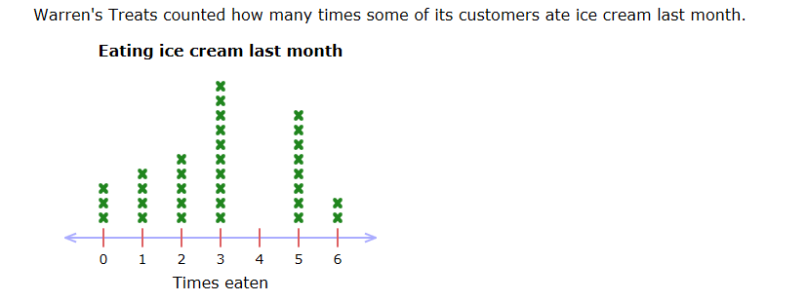
How many customers didn’t eat any ice cream? ____________________
How many customers ate ice cream at least three times? ____________________
How many customers ate ice cream less than three times? ____________________

