Name:
Area and Perimeter
Find the missing length or width:
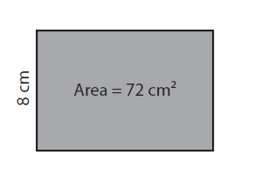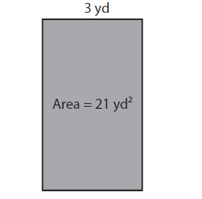
Length: ________________ Length: ________________
Perimeter: ________________ Perimeter: ________________

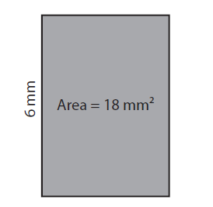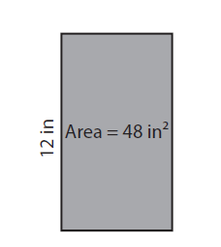
Length: ________________ Length: ________________
Perimeter: ________________ Perimeter: ________________

